Acid-Base Titrations
An acid-base titration is when you add a base to an acid until the equivalence point is reached which is where the moles of acid equals the moles of base. For the titration of a strong base and a strong acid, this equivalence point is reached when the pH of the solution is seven (7) as seen on the following titration curve:
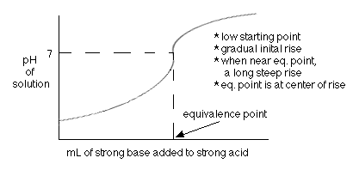
For the titration of a strong base with a weak acid, the equivalence point is reached when the pH is greater than seven (7). The half equivalence point is when half of the total amount of base needed to neutralize the acid has been added. It is at this point where the pH = pK_{a} of the weak acid.
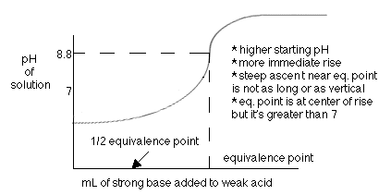
In an acid-base titration, the base will react with the weak acid and form a solution that contains the weak acid and its conjugate base until the acid is completely gone. To solve these types of problems, we will use the weak acid's K_{a} value and the molarities in a similar way as we have before. Before demonstrating this way, let us first examine a short cut, called the Henderson-Hasselbalch Equation. This can only be used when you have some acid and some conjugate base in your solution. If you only have acid, then you must do a pure K_{a} problem and if you only have base (like when the titration is complete) then you must do a K_{b} problem.

